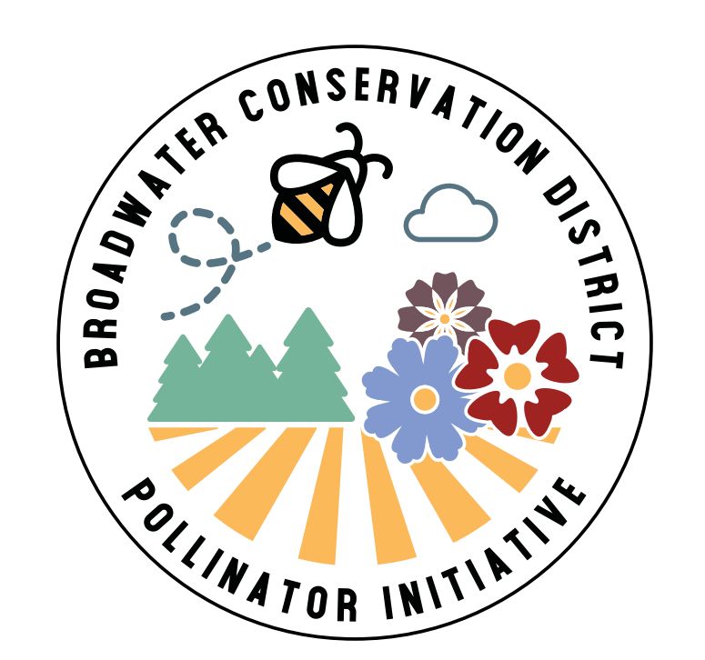
Broadwater Pollinator Initiative
Cooperator Interest Form

Please fill out and submit to: broadwatercd@macdnet.org
or 415 S Front Street, Townsend, MT 59644

Name: ____________________________ Physical Address: ____________________________________

Email: ____________________________ Mailing Address: ____________________________________

Phone: ____________________________

Requested Plot Size (Max 2,500 square feet): _________________________________

Describe current site conditions (bare ground, forested, grasses, weeds, etc):

____________________________________________________________________________________________

I understand that pollinator seeds are provided through grant funding from DNRC. Broadwater Conservation District collects recipient information for grant tracking purposes and will not use this information for any other purpose. We would love to see photos of your flowers when they come up!

Cooperator Signature: ______________________________________________ Date: ___________________

