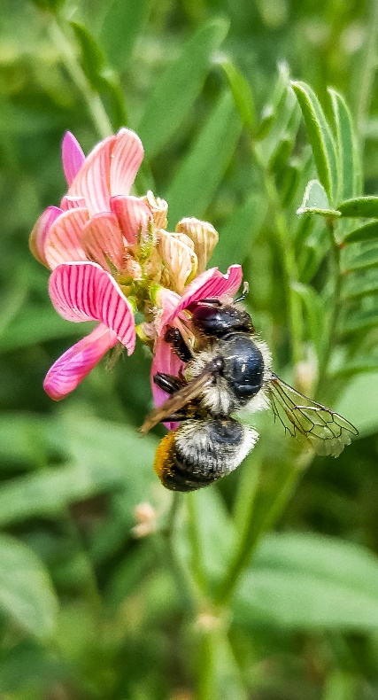
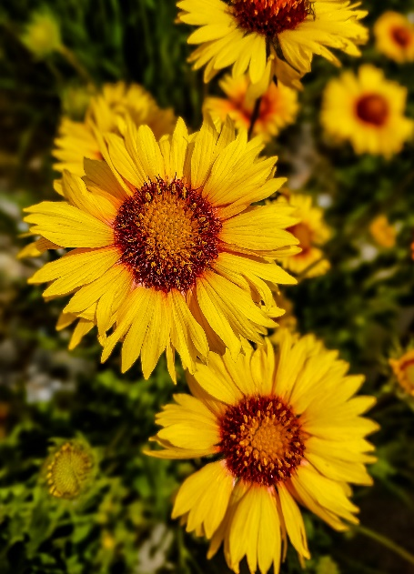
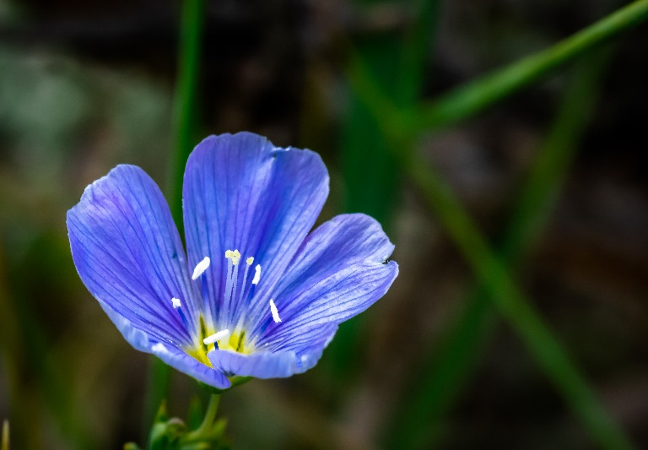
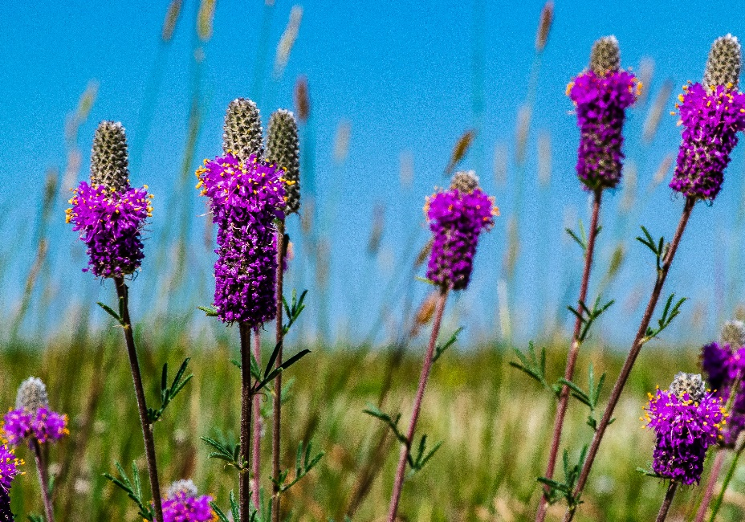
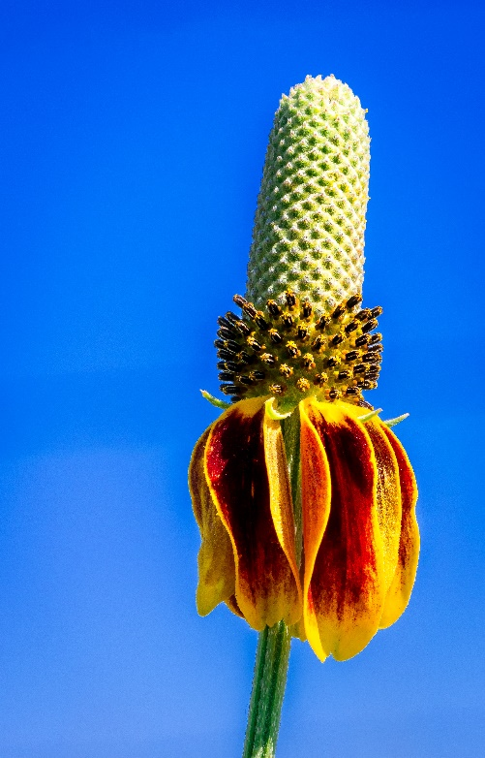

Broadwater Conservation District Pollinator Initiative

Pollinator Garden Planting Guide

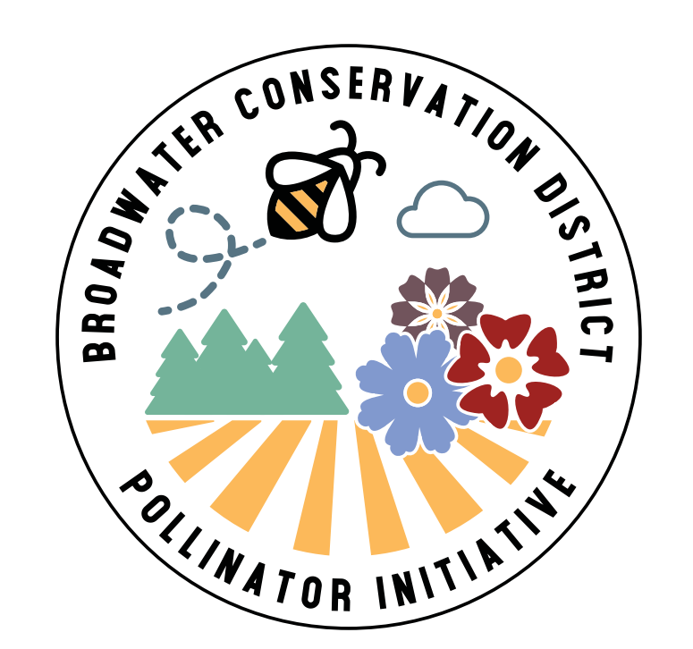
Pollinators live in a wide variety of habitats and use a wide variety of pollen sources. Pollinator gardens are a great way to increase food sources for native pollinators and beneficial insects. Flowers of all different sizes, shapes, and colors are represented in our mixes to attract a wide variety of insects and other pollinating species. The mix includes flowers that bloom at different times throughout the season to assure pollinators will have a food source all season long. Some of the insects that are attracted to pollinator gardens include bees, butterflies, and moths!
We can thank pollinators for one out of three bites of food we take, so why not give back?

Site Preparations:

The success of any new seeding is largely dependent upon the condition of the seedbed into which it is seeded. A clean, weed-free seedbed is critical for optimizing success. Seedbed preparation is dependent upon the site location, existing species present and other factors. Below is a guideline for preparing the seedbed for your pollinator garden.

Step 1: Determine existing species on the site location:

If the site is currently covered in grass or other vegetation it must be treated to remove and kill this competitive vegetation. New plants, especially flowering plants, cannot compete well against existing vegetation and the seeding will fail if existing vegetation is not first controlled.

- Existing Site is Clean, Bare Ground: Keep the area clean before seeding. Proceed to Step 3.

- Existing Grass or Annual Weed Vegetation: Site must be prepped using a combination of mowing, burning, herbicide, tillage, or other suitable means. Proceed to Step 2.

- Noxious Weed Infestation: Treat the area with an herbicide for at least a full year before planting a pollinator garden. Consider using our Non-Native mix to help compete against noxious weeds in the future. Proceed to Step 2.

Step 2: Control Existing Vegetation

Terminate the existing vegetation using one or a combination of the methods listed below. A full-spectrum herbicide like glyphosate can be used to kill all actively growing vegetation. Tillage can then be used to break the sod and prepare the seedbed. Mowing and/or burning can remove dead, existing vegetation. A combination of herbicide + tillage is the most effective means of preparing the seedbed. However, if you choose not to use herbicide more tillage and/or other methods will be required. The success rate of the seeding will depend on the type of existing vegetation present and seed bed prep that has been taken.

- Use Chemical + Tillage: If large amounts of dead vegetation are present, mow or burn the area first, immediately. As soon as plants begin to actively grow (turn green), apply glyphosate following label recommendations to kill the vegetation. Wait 10 days for plants to die. Till the soil to break sod and smooth the area. Irrigate immediately, if possible, to allow any weed seeds or rhizomatous grasses to re-grow. 14 days after tillage, reapply glyphosate to kill re-growing plants. If the site has extremely completive vegetation repeat the herbicide application one more time. Three days after your last herbicide application you are ready to seed. Proceed to Step 3.

- Use Tillage Only: If the site has dead vegetation present burn or mow the site and then immediately till as soon as possible in the spring to break the sod and smooth the area. Wait 10-14 days (allowing plants to germinate) and re-till and re-smooth the area to kill any re-growing grass/weeds. If possible, repeat this process once more. Ideally complete 2-3 tillage operations in the spring before planting. Proceed to Step 3.

- Solarization: Solarization is the process of using the sun and a clear plastic tarp to concentrate the suns energy to kill life within the soil, including weeds. This process takes time. Clear and till the areas to be seeded and lay a clear or black plastic tarp on the areas for at least two months between June and August. Proceed to Step 3 for a fall planting.

Site Preparations Continued:

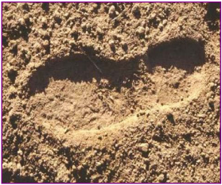
Step 3: Final Seedbed Preparation:

Make sure the area to be seeded is smooth and free of any clods larger than 2”. Smooth the area with a rake or a harrow pulled behind a small tractor, ATV or a riding lawnmower. When you step on a well-prepared seedbed your boot should sink into the ground no deeper than 1/8”. Proceed to Step 4.

Step 4: Seeding:

Broadcast the seed evenly over the plot area. Immediately after seeding lightly rake or harrow the site to incorporate seed into the upper ¼” of the soil. Be careful not to harrow too deeply because most flowering plants have small seeds and need to be just below the surface. For non-irrigated sites, spring seeding should be done no later than May 15^{sth}. If seed bed prep cannot be completed before May 15th, prepare seed bed during the summer and seed in fall (after October 15th) or the following spring. For irrigated sites, seeding can occur up until June 15th or after September 1st.

Step 5: Post-Seeding:

If possible, apply light, frequent irrigations to the site for the first 2 months following seeding. The goal should be to keep the ground moist, but not over saturated. After the plot is established, irrigation is recommended, but not necessary because the species we have selected do well in dryland environments. However, applying some irrigations whenever possible will likely benefit your plot into the future.

Step 6: Managing Weeds:

Weeds pose the greatest threat to pollinator plantings. Herbicide can be an effective but challenging tool because applying herbicide to kill weeds can also kill your desired plants. The best way to minimize weeds is to start with a clean seedbed (see above) and manage the seeding in the first two years to control weeds by mowing, hand-pulling and/or with careful herbicide usage. For locations that may need to deal with extended weed competition, consider seeding our Non-Native seed mix. This mix includes species that aren’t native to Montana, but still serve as beneficial pollinator habitat and are more capable of competing with weeds.

- Mowing: Mowing weeds during the first year or two of establishment can be extremely effective. The goal is to eliminate seed production from annual weeds, so they do not continue to proliferate within your plot. If weed pressure is high the problem areas would be mowed or cut before weeds go to seed. Set the more blades as high as possible (6” to 10”) and mow the area to remove the tops of the weeds. Or use a weed-eater or other device to cut the problem areas within the plot. Mowing may be necessary 2-3 times (or more) during each of the first two years of seeding.

- Hand Pulling: Hand pulling can be an extremely effective small plot strategy. Hand-pulling can be laborious, but there is little substitute for well-managed hand pulling of weeds.

- Spot Spraying: Spot spraying weeds within your garden can be effective if caution is used. Be extremely careful not to apply herbicide onto your desired plants. A broad-spectrum herbicide like glyphosate is a good option if applied to the actively growing parts of the weed. Avoid herbicides that have residual effects in the soil after application (including most broadleaf herbicides). If your plot contains only flowering plants, a herbicide specific for grass can be effectively used to control aggressive grass species like quack grass, smooth brome, and Kentucky bluegrass. Be careful not to eliminate grasses that have been included in the mixes.
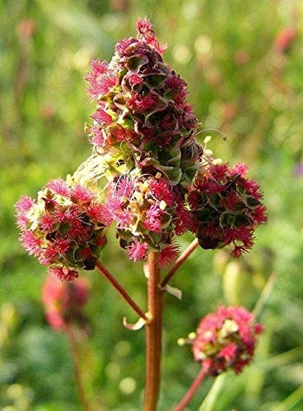
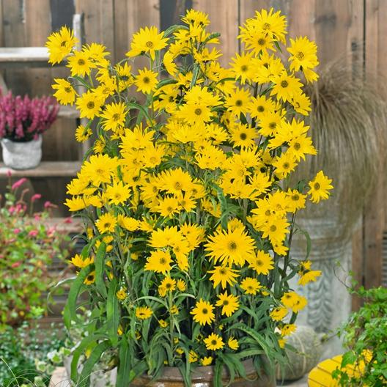
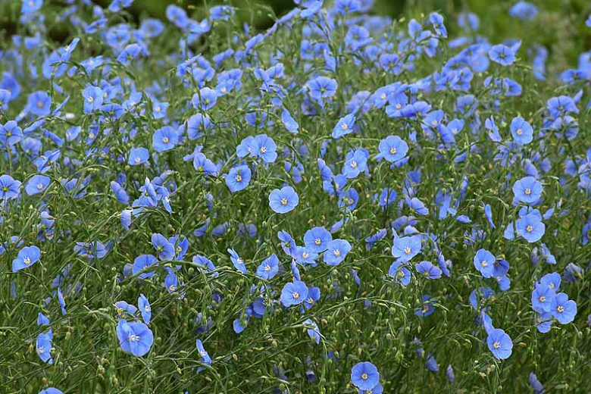
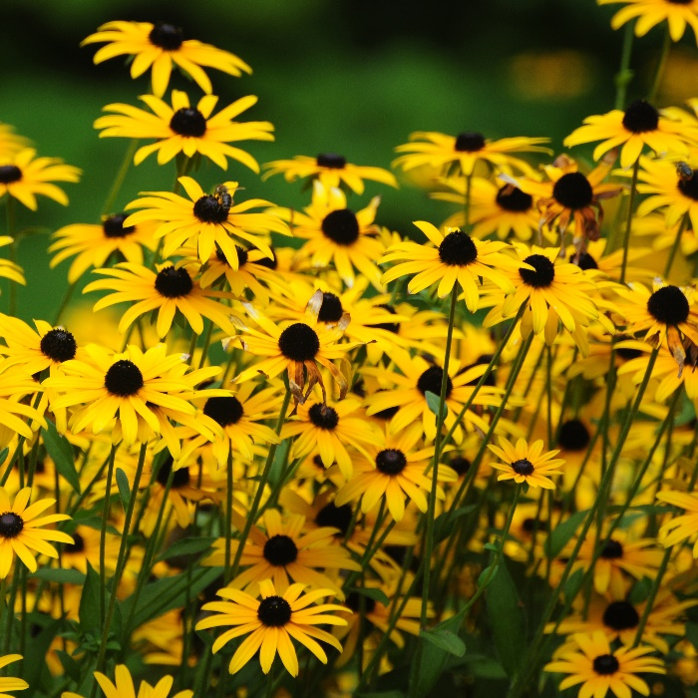

Pollinator Garden Tip:
Supplement your pollinator garden by adding trees and shrubs from local nurseries or by adding small plugs.
Contact the Broadwater Conservation District with questions:

Phone: 406-521-3016
Email: BroadwaterCD@gmail.com

